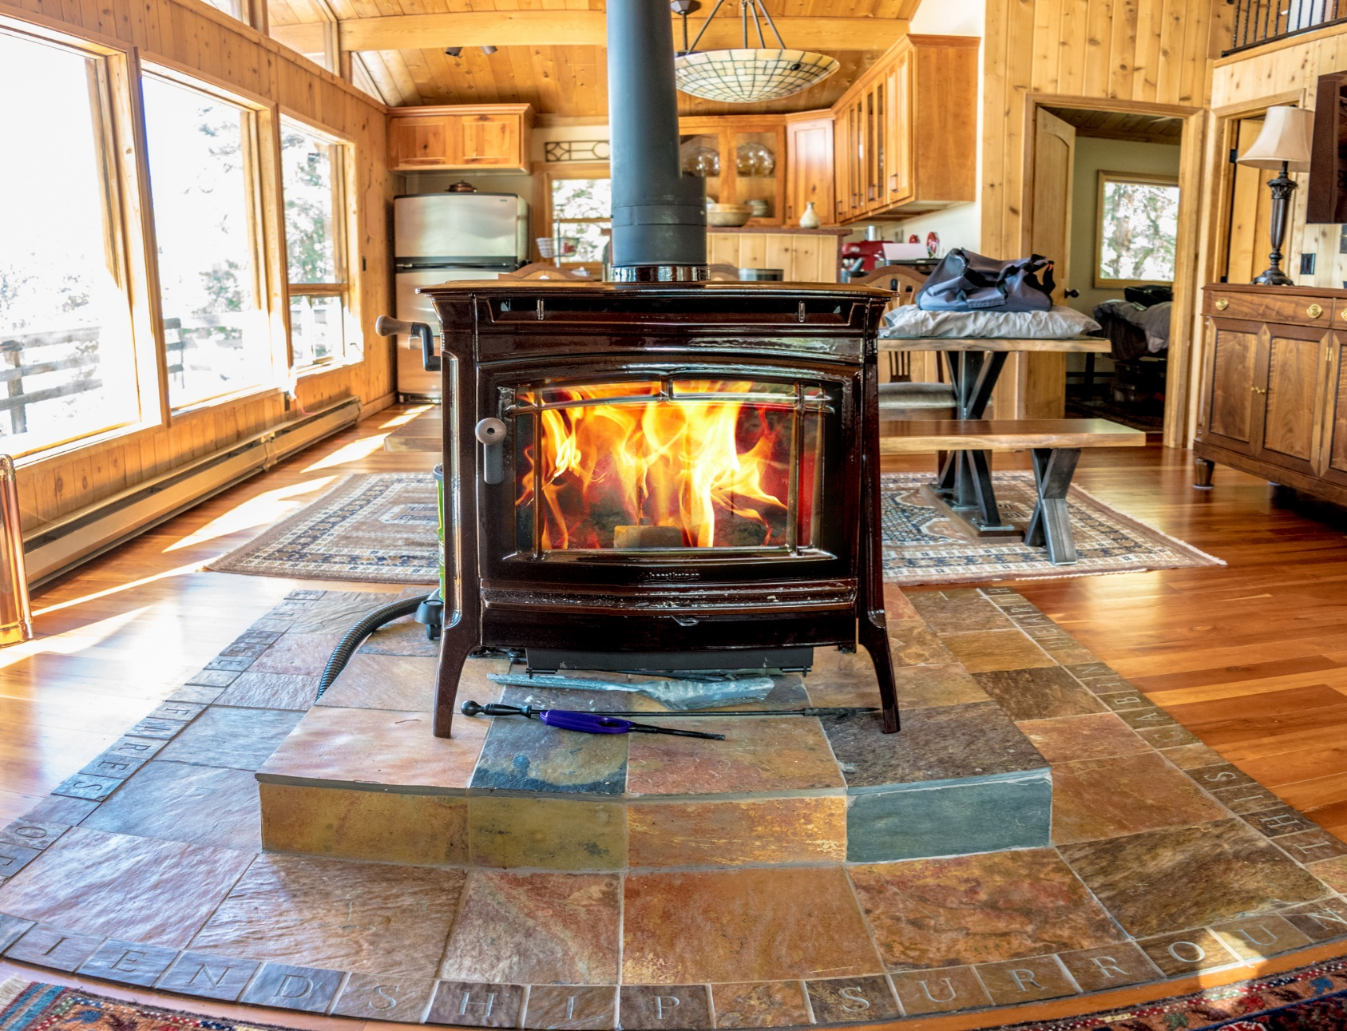

**Attn: Splatsin Band Members**

RE: 2023/2024 Firewood

The public works department has firewood available.

A load will be delivered to those who complete the form below…

**PLEASE NOTE:** **REQUESTS DEPEND ON WOOD AVAILABILITY AND PRIORITY.** WE PRIORITIZE ASSISTING THOSE IN NEED. WE APPRECIATE YOUR PATIENCE AND UNDERSTANDING WHEN IT COMES TO THE TIMELINES OF DELIVERIES.

IF YOU ARE ABLE TO PICK UP THE WOOD YOURSELF, PLEASE MAKE ARRANGEMENTS AND THE WOOD CREW WILL GLADLY HELP LOAD IT FOR YOU.

**FIREWOOD REQUEST FORM 2023 / 2024**

DATE: ___________________________________, 20________

HOMEOWNER/ RESIDENT’S NAME: ________________________________________________

ADDRESS: _____________________________________________________________________

# OF PEOPLE RESIDING AT THE ABOVE ADDRESS: _______________________

PHONE #: _________________________ EMAIL: _________________________________

DO YOU HAVE BACK UP HEAT? YES ______________ NO _________________

SIGNATURE: __________________________________________________________

IF YOU HAVE ANY QUESTIONS, PLEASE CONTACT THE FRONT DESK

(250)838-6496